*TUDORS*

**1570 - Sir Francis Drake sets sail for his first Voyage to the West Indies**

**1544 – Henry VIII invades northern France**

**1492 – Christopher Columbus discovered the West Indies.**

**LADY JANE GREY**

**Only lasted in reign for 9 days.**

**1485 – War of the roses ended.**

**1509**

**HENRY VIII**

**1547**

**EDWARD VI**

**1553**

**MARY I**

**1558**

**ELIZABETH 1**

**HENRY VII**

**1603**

**1485**

  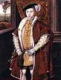 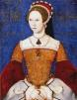 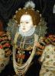

**Population of Britain 3.2m**

**QUEEN ELIZABETH I DIED**